In

[1]:

In

[2]:

In

[3]:

In

[4]:

Out[4]:

*# Importing the necessary libraries*

**import**

numpy

**as**

np

**import**

pandas

**as**

pd

**import**

matplotlib

.

pyplot

**as**

plt

**import**

seaborn

**as**

sns

**from**

scipy

.

stats

**import**

ttest_ind

,

f_oneway

,

levene

,

kruskal

,

shapiro

,

chi2_c

**from**

statsmodels

.

graphics

.

gofplots

**import**

qqplot

**import**

warnings

warnings

.

filterwarnings

(

"ignore"

)

*# converting data into dataframe*

yulu

**=**

pd

.

read_csv

(

'bike_sharing.csv'

)

*# making an copy of the dataset*

df

**=**

yulu

.

copy

()

*# Top 5 rows of the dataframe*

df

.

head

()

**datetime season holiday workingday weather temp atemp humidity windspeed casu**

2011-01-

1. 01 1 0 0 1 9.84 14.395 81 0.0

00:00:00

2011-01-

1. 01 1 0 0 1 9.02 13.635 80 0.0

01:00:00

2011-01-

1. 01 1 0 0 1 9.02 13.635 80 0.0

02:00:00

2011-01-

1. 01 1 0 0 1 9.84 14.395 75 0.0

03:00:00

2011-01-

1. 01 1 0 0 1 9.84 14.395 75 0.0

04:00:00

In

[5]:

**

**

Out[5]:

(10886, 12)

*# No of rows and columns*

df

.

shape

In

[6]:

*# Checking of null values*

df

.

isna

().

sum

()

Out[6]: datetime 0 season 0 holiday 0 workingday 0 weather 0 temp 0 atemp 0 humidity 0 windspeed 0 casual 0 registered 0 count 0 dtype: int64

**There are totally 10886 rows and 12 columns in the data**

**The data does not contain any nulls, thus no need of handling the missing data.**

In

[7]:

*# Duplicate values check*

df

.

duplicated

().

sum

()

Out[7]: 0

In

[8]:

*# skewness of each column*

df

.

skew

(

numeric_only

**=**

**True**

)

Out[8]: season -0.007076 holiday 5.660517 workingday -0.776163 weather 1.243484 temp 0.003691 atemp -0.102560 humidity -0.086335 windspeed 0.588767 casual 2.495748 registered 1.524805 count 1.242066 dtype: float64

**Skewness Analysis of Variables Symmetrical Majority:**

The majority of the variables, including 'season' and 'temp', exhibit skewness values close to zero, suggesting relatively symmetrical distributions.

**Positive Skewness Insights:**

Variables such as 'holiday', 'weather', 'windspeed', 'casual', 'registered', and 'count' demonstrate positive skewness, pointing to a concentration of lower values and a rightward skew in their distributions.

**Negative Skewness Observations:**

In contrast, 'workingday', 'atemp', and 'humidity' exhibit negative skewness, implying a concentration of higher values and a leftward skew in their distributions.

In

[9]:

*# Uniques values of each columns*

df

.

nunique

()

Out[9]: datetime 10886 season 4 holiday 2 workingday 2 weather 4

temp 49 atemp 60 humidity 89 windspeed 28 casual 309 registered 731 count 822 dtype: int64

In

[10]:

*# data info*

df

.

info

()

<class 'pandas.core.frame.DataFrame'>

RangeIndex: 10886 entries, 0 to 10885 Data columns (total 12 columns):

# Column Non-Null Count Dtype

--- ------ -------------- -----

1. datetime 10886 non-null object
2. season 10886 non-null int64
3. holiday 10886 non-null int64
4. workingday 10886 non-null int64
5. weather 10886 non-null int64
6. temp 10886 non-null float64
7. atemp 10886 non-null float64
8. humidity 10886 non-null int64
9. windspeed 10886 non-null float64
10. casual 10886 non-null int64
11. registered 10886 non-null int64
12. count 10886 non-null int64 dtypes: float64(3), int64(8), object(1) memory usage: 1020.7+ KB

In [11]: *# count column is sum of casual and the registered users*

(df['casual'] **+** df['registered'] **==** df['count']).value_counts()

Out[11]: True 10886

Name: count, dtype: int64

[12]:

>

<

class 'pandas.core.frame.DataFrame'

*# converting the categorical columns into category*

cat_col

**=**

[

'season'

,

'holiday'

,

'workingday'

,

'weather'

]

**for**

_

**in**

cat_col

:

df

[

_

]

**=**

df

[

_

].

astype

(

'category'

)

df

.

info

()

RangeIndex: 10886 entries, 0 to 10885 Data columns (total 12 columns):

# Column Non-Null Count Dtype

--- ------ -------------- -----

1. datetime 10886 non-null object
2. season 10886 non-null category
3. holiday 10886 non-null category
4. workingday 10886 non-null category
5. weather 10886 non-null category
6. temp 10886 non-null float64
7. atemp 10886 non-null float64
8. humidity 10886 non-null int64
9. windspeed 10886 non-null float64
10. casual 10886 non-null int64
11. registered 10886 non-null int64
12. count 10886 non-null int64 dtypes: category(4), float64(3), int64(4), object(1) memory usage: 723.7+ KB

In

[13]:

Out[13]:

dtype('<M8[ns]')

*# Converting datetime column into date time format*

df

[

'datetime'

]

**=**

pd

.

to_datetime

(

df

[

'datetime'

])

df

[

'datetime'

].

dtype

In

[14]:

In

[15]:

Out[15]:

*# Creating new columns from datetime and converting them to categories*

df

[

'year'

]

**=**

df

[

'datetime'

].

dt

.

year

df

[

'month'

]

**=**

df

[

'datetime'

].

dt

.

month

df

[

'day'

]

**=**

df

[

'datetime'

].

dt

.

day

df

[

'hour'

]

**=**

df

[

'datetime'

].

dt

.

hour

df

.

head

(

2

)

**datetime season holiday workingday weather temp atemp humidity windspeed casu**

2011-01-

1. 01 1 0 0 1 9.84 14.395 81 0.0

00:00:00

2011-01-

1. 01 1 0 0 1 9.02 13.635 80 0.0

01:00:00

**

**

[16]: *# replacing the number with category*

*# change of season*

df['season'] **=** df['season'].replace({1:'Spring',2:'Summer',3:'Fall',4:'Winte

*# change of holiday*

df['holiday'] **=** df['holiday'].replace({0:'No',1:'Yes'})

*# change of workingday*

df['workingday'] **=** df['workingday'].replace({0:'No',1:'Yes'})

*# change of month*

df['month'] **=** df['month'].replace({1: 'January', 2: 'February',

3: 'March',

4: 'April',

5: 'May',

6: 'June',

7: 'July',

8: 'August',

9: 'September', 10: 'October',

11: 'November',

12: 'December'})

In [17]: df.describe().transpose()

Out[17]:

**count mean min 25% 50% 75% max**

2011- 2011- 2012- 2012- 2012-

2011-12-27

**datetime** 10886 01-01 07-02 01-01 07-01 12-19

05:56:22.399411968

00:00:00 07:15:00 20:30:00 12:45:00 23:00:00

**temp** 10886.0 20.23086 0.82 13.94 20.5 26.24 41.0 7.

**atemp** 10886.0 23.655084 0.76 16.665 24.24 31.06 45.455 8.4

**humidity** 10886.0 61.88646 0.0 47.0 62.0 77.0 100.0 19.2

**windspeed** 10886.0 12.799395 0.0 7.0015 12.998 16.9979 56.9969 8.1

**casual** 10886.0 36.021955 0.0 4.0 17.0 49.0 367.0 49.9

**registered** 10886.0 155.552177 0.0 36.0 118.0 222.0 886.0 151.0

**count** 10886.0 191.574132 1.0 42.0 145.0 284.0 977.0 181.1

**year** 10886.0 2011.501929 2011.0 2011.0 2012.0 2012.0 2012.0 0.5

**day** 10886.0 9.992559 1.0 5.0 10.0 15.0 19.0 5.4

**hour** 10886.0 11.541613 0.0 6.0 12.0 18.0 23.0 6.9

**

**

[18]:

df

.

describe

(

include

**=**

'category'

).

transpose

()

Out[18]:

**count unique top freq**

|  |  |  |  |  |
| --- | --- | --- | --- | --- |
| **season** | 10886 | 4 | Winter | 2734 |
| **holiday** | 10886 | 2 | No | 10575 |
| **workingday** | 10886 | 2 | Yes | 7412 |
| **weather** | 10886 | 4 | 1 | 7192 |

**Overview and Feature Patterns**

**Temporal and Numerical Composition:**

The dataset encompasses both datetime information and various numerical features associated with bike rentals. The observations span from January 1, 2011, to December 19, 2012.

**Diverse Numerical Feature Characteristics:**

Numerical features such as temperature, humidity, windspeed, and counts of casual and registered bike rentals show diverse ranges and distributions, highlighting the variability in rental patterns across different conditions.

**Temporal Patterns and Concentrations:**

Observations on the year, day, and hour variables indicate temporal patterns, with a concentration in 2011 and 2012, a mean day value around 10, and an hourly distribution ranging from 0 to 23.

# Outlier Detection

[19]:

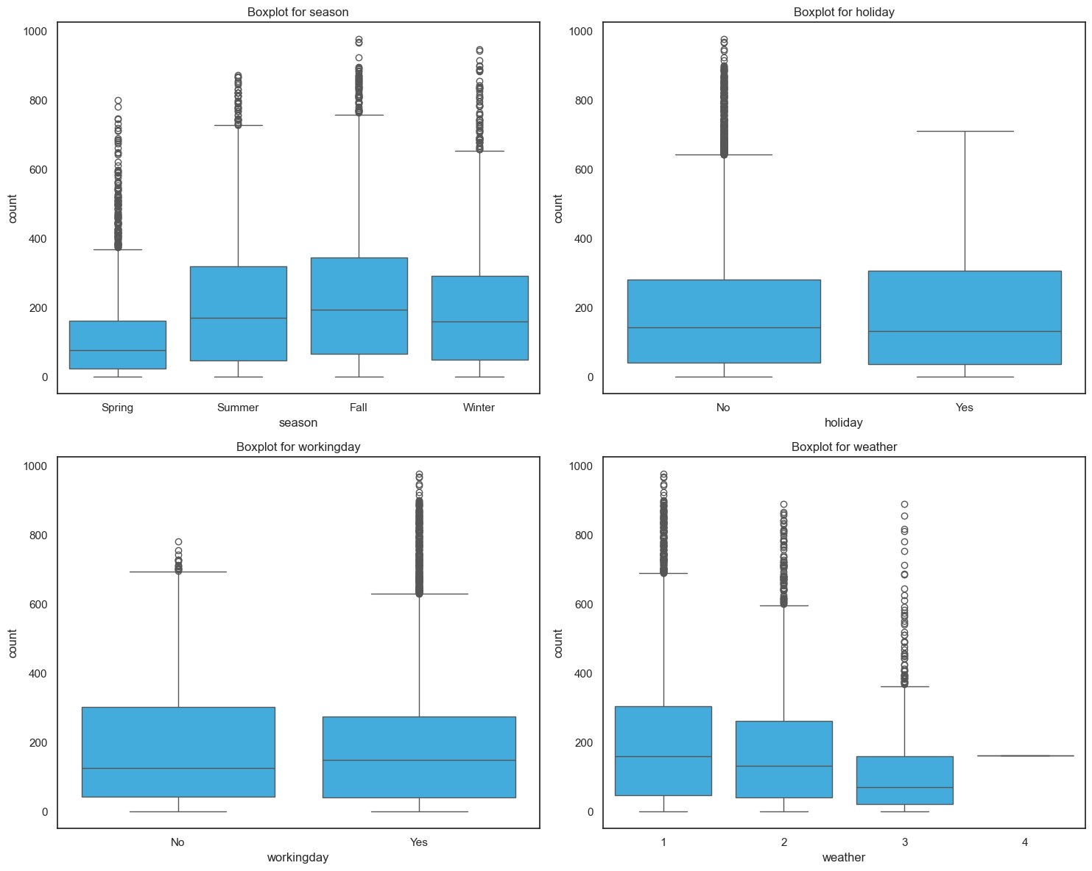

plt

.

figure

(

figsize

**=**

(

15

,

12

))

sns

.

set

(

style

**=**

"white"

)

**for**

i

,

column

**in**

enumerate

(

cat_col

,

1

):

plt

.

subplot

(

2

,

2

,

i

)

sns

.

boxplot

(

x

**=**

column

,

y

**=**

'count'

,

data

**=**

df

,

color

**=**

"#29B6F6"

)

plt

.

title

(

f'Boxplot for

{

column

}

'

)

plt

.

tight_layout

()

plt

.

show

()

**Outlier Analysis**

**Outliers in Different Seasons:**

In spring and winter, there are more unusual values in the data compared to other seasons.

**Weather Outliers:**

Category 3 weather has a lot of unusual values, while category 4 weather doesn't have any.

**Working Days vs. Holidays:**

On regular working days, there are more unusual values in the data than on holidays. This suggests some unexpected patterns during typical workdays that might need a closer look.

# Univariate Analysis

In

[20]:

*# Time span of data*

time_span

**=**

df

[

'datetime'

].

max

()

**-**

df

[

'datetime'

].

min

()

time_span

Out[20]: Timedelta('718 days 23:00:00')

In

[21]:

df

.

columns

Out[21]: Index(['datetime', 'season', 'holiday', 'workingday', 'weather', 'temp',

'atemp', 'humidity', 'windspeed', 'casual', 'registered', 'count',

'year', 'month', 'day', 'hour'], dtype='object')

In

[22]:

*# Season counts*

df

[

'season'

].

value_counts

()

Out[22]: season

Winter 2734

Summer 2733

Fall 2733

Spring 2686

Name: count, dtype: int64

In

[23]:

*# holiday counts*

df

[

'holiday'

].

value_counts

()

Out[23]: holiday

No 10575

Yes 311

Name: count, dtype: int64

In

[24]:

*# workingday counts*

df

[

'workingday'

].

value_counts

()

Out[24]: workingday

Yes 7412

No 3474

Name: count, dtype: int64

In

[25]:

*# weather counts*

df

[

'weather'

].

value_counts

()

Out[25]: weather

1. 7192
2. 2834
3. 859
4. 1

Name: count, dtype: int64

[26]:

*# year counts*

df

[

'year'

].

value_counts

()

Out[26]: year

2012 5464

2011 5422

Name: count, dtype: int64

In

[27]:

*# month counts*

df

[

'month'

].

value_counts

()

Out[27]: month

May 912

June 912

July 912

August 912

December 912

October 911

November 911

April 909

September 909

February 901

March 901

January 884

Name: count, dtype: int64

In

[28]:

*# day counts*

df

[

'day'

].

value_counts

().

sort_index

()

Out[28]: day

1. 575
2. 573
3. 573
4. 574
5. 575
6. 572
7. 574
8. 574
9. 575
10. 572
11. 568
12. 573
13. 574
14. 574
15. 574
16. 574
17. 575
18. 563
19. 574

Name: count, dtype: int64

[29]:

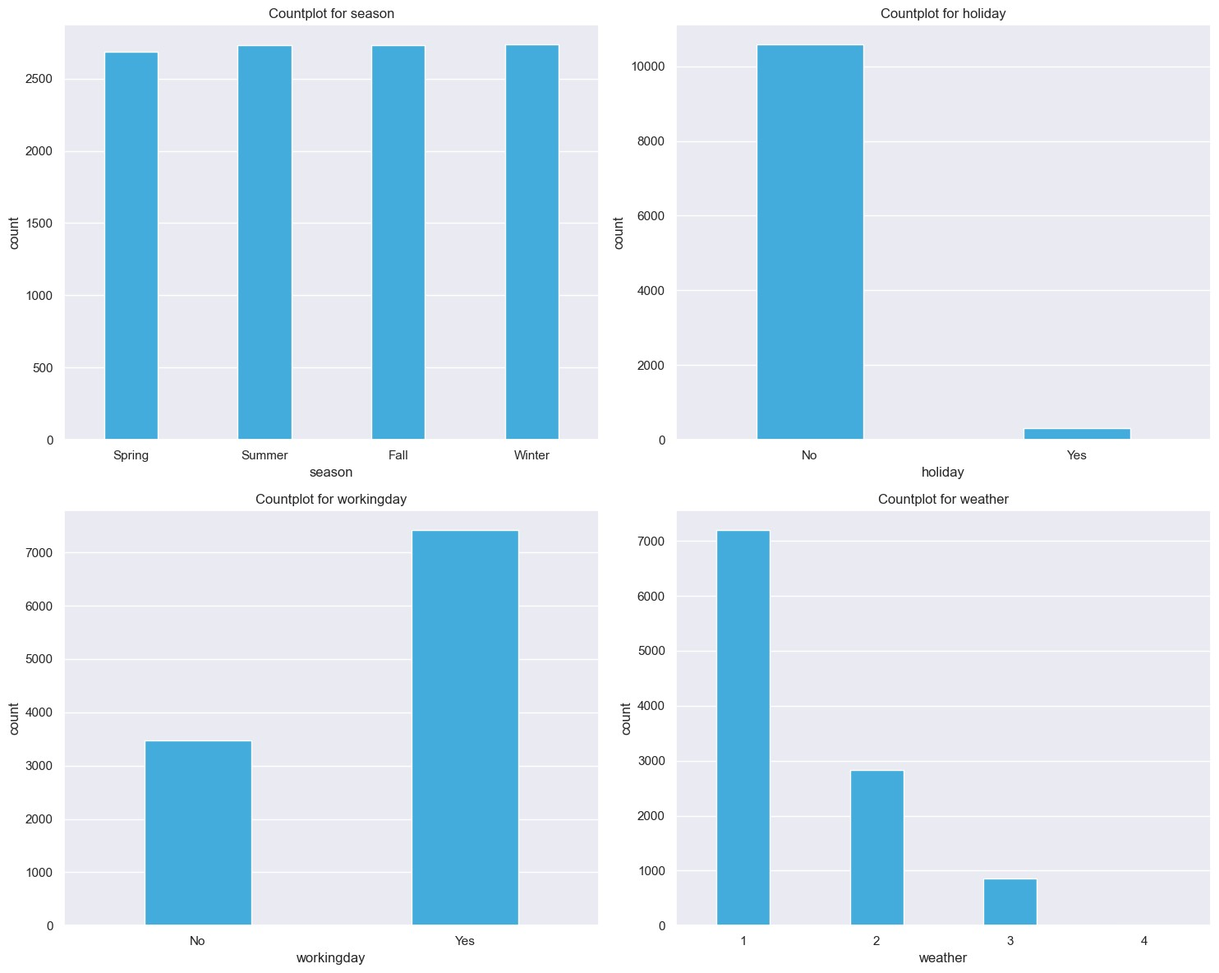

*# countplot on categories*

plt

.

figure

(

figsize

**=**

(

15

,

12

))

sns

.

set

(

style

**=**

"darkgrid"

)

**for**

i

,

column

**in**

enumerate

(

cat_col

,

1

):

plt

.

subplot

(

2

,

2

,

i

)

sns

.

countplot

(

x

**=**

column

,

data

**=**

df

,

color

**=**

"#29B6F6"

,

width

**=**

0.4

)

plt

.

title

(

f'Countplot for

{

column

}

'

)

plt

.

tight_layout

()

plt

.

show

()

[30]:

*# Function for histogram & boxplot on numerical columns*

**def**

hist_box

(

column

):

f

,

axs

**=**

plt

.

subplots

(

1

,

2

,

figsize

**=**

(

10

,

5

))

sns

.

set

(

style

**=**

"darkgrid"

)

*# Histogram*

plt

.

subplot

(

1

,

2

,

1

)

sns

.

histplot

(

df

[

column

]

,

bins

**=**

20

,

kde

**=**

**True**

)

plt

.

title

(

f'Histogram for

{

column

}

'

)

*# Boxplot*

plt

.

subplot

(

1

,

2

,

2

)

sns

.

boxplot

(

df

[

column

]

,

color

**=**

"#29B6F6"

)

plt

.

title

(

f'Boxplot for

{

column

}

'

)

tabular_data

**=**

df

[

column

].

describe

().

reset_index

()

tabular_data

.

columns

**=**

[

'Statistic'

,

'Value'

]

display

(

tabular_data

)

plt

.

tight_layout

()

plt

.

show

()

[31]:

num_col

**=**

[

'temp'

,

'atemp'

,

'humidity'

,

'windspeed'

,

'casual'

,

'registered'

,

**for**

column

**in**

num_col

:

hist_box

(

column

)

**Statistic Value**

|  |  |
| --- | --- |
| **0** count | 10886.00000 |
| **1** mean | 20.23086 |
| **2** std | 7.79159 |
| **3** min | 0.82000 |
| **4** 25% | 13.94000 |
| **5** 50% | 20.50000 |
| **6** 75% | 26.24000 |
| **7** max | 41.00000 |

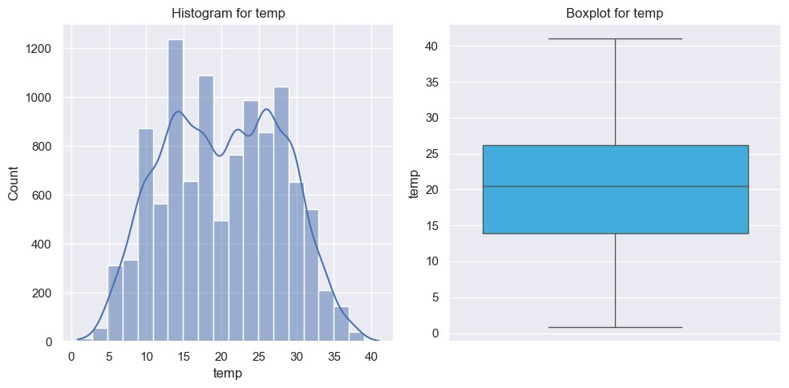

**Statistic Value**

|  |  |
| --- | --- |
| **0** count | 10886.000000 |
| **1** mean | 23.655084 |
| **2** std | 8.474601 |
| **3** min | 0.760000 |
| **4** 25% | 16.665000 |
| **5** 50% | 24.240000 |
| **6** 75% | 31.060000 |
| **7** max | 45.455000 |

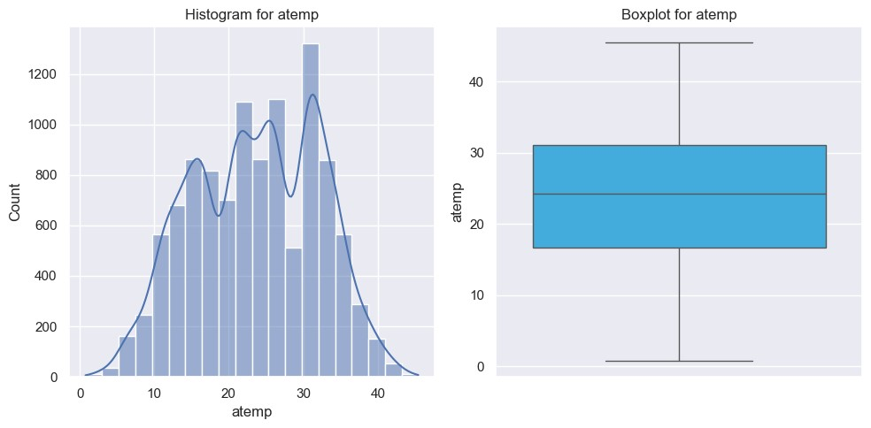

**Statistic Value**

|  |  |  |
| --- | --- | --- |
| **0** | count | 10886.000000 |
| **1** | mean | 61.886460 |
| **2** | std | 19.245033 |
| **3** | min | 0.000000 |
| **4** | 25% | 47.000000 |
| **5** | 50% | 62.000000 |
| **6** | 75% | 77.000000 |
| **7** | max | 100.000000 |

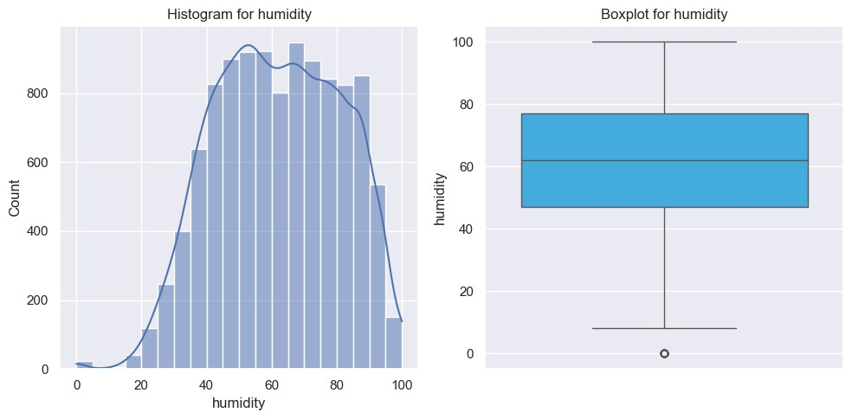

**Statistic Value**

|  |  |
| --- | --- |
| **0** count | 10886.000000 |
| **1** mean | 12.799395 |
| **2** std | 8.164537 |
| **3** min | 0.000000 |
| **4** 25% | 7.001500 |
| **5** 50% | 12.998000 |
| **6** 75% | 16.997900 |
| **7** max | 56.996900 |

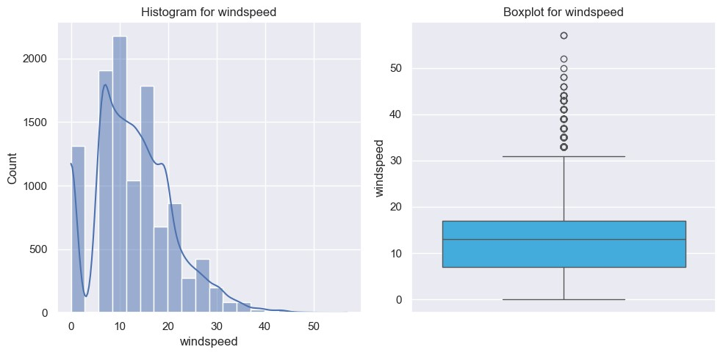

**Statistic Value**

|  |  |  |
| --- | --- | --- |
| **0** | count | 10886.000000 |
| **1** | mean | 36.021955 |
| **2** | std | 49.960477 |
| **3** | min | 0.000000 |
| **4** | 25% | 4.000000 |
| **5** | 50% | 17.000000 |
| **6** | 75% | 49.000000 |
| **7** | max | 367.000000 |

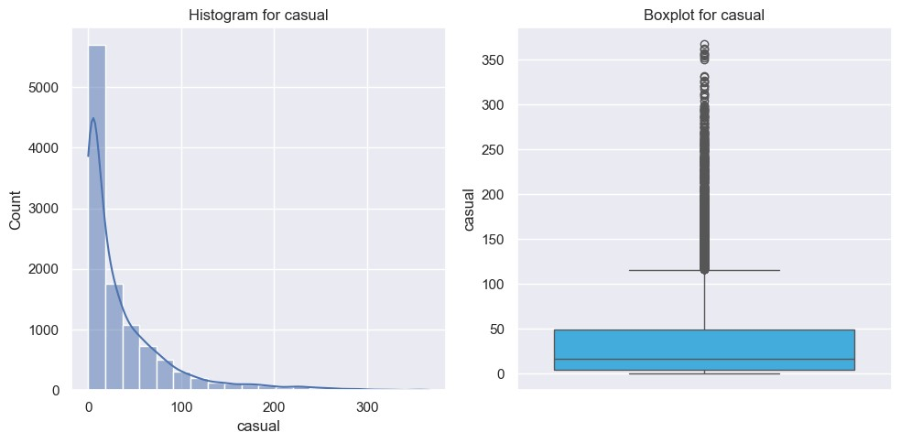

**Statistic Value**

|  |  |  |
| --- | --- | --- |
| **0** | count | 10886.000000 |
| **1** | mean | 155.552177 |
| **2** | std | 151.039033 |
| **3** | min | 0.000000 |
| **4** | 25% | 36.000000 |
| **5** | 50% | 118.000000 |
| **6** | 75% | 222.000000 |
| **7** | max | 886.000000 |

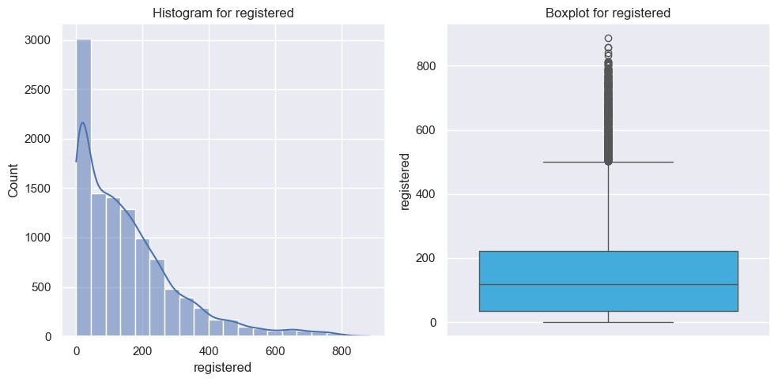

**Statistic Value**

|  |  |  |
| --- | --- | --- |
| **0** | count | 10886.000000 |
| **1** | mean | 191.574132 |
| **2** | std | 181.144454 |
| **3** | min | 1.000000 |
| **4** | 25% | 42.000000 |
| **5** | 50% | 145.000000 |
| **6** | 75% | 284.000000 |
| **7** | max | 977.000000 |

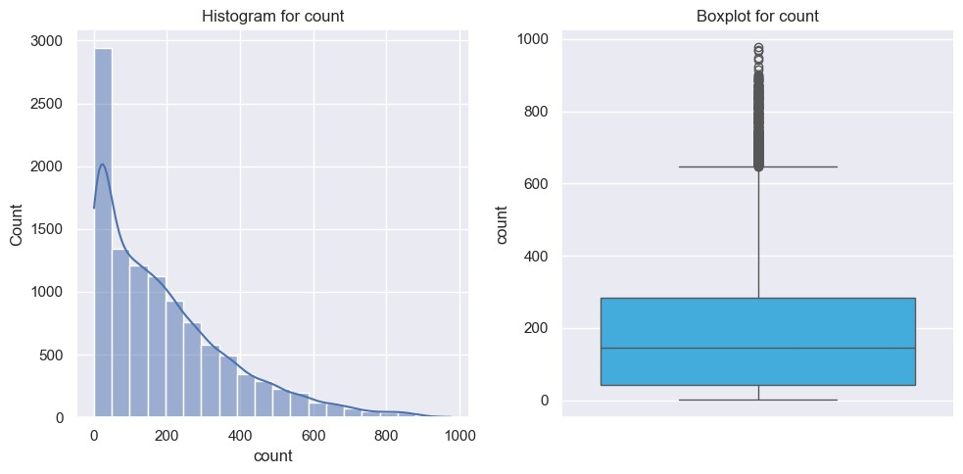

**Numerical column analysis Temp:**

The 'temp' column shows a diverse temperature range (0.82 to 41.0), with a median of

20.5 and moderate variability around the mean of approximately 20.23 degrees Celsius.

**Atemp**

The 'atemp' column displays a wide range of apparent temperatures (0.76 to 45.455), with a mean of approximately 23.66 and moderate variability around the median of

24.24.

**Humidity**

The 'humidity' column depicts a range of humidity values (0 to 100), with an average around 61.89. The distribution shows moderate variability, from 47 at the 25th percentile to 77 at the 75th percentile, indicating diverse humidity levels in the dataset.

**WindSpeed**

The 'windspeed' column displays a range of wind speeds from 0 to 56.9979, with a mean of approximately 12.80.

**Casual**

The 'casual' column demonstrates a broad range of casual bike rental counts, with values spanning from 0 to 367. The distribution is positively skewed, as indicated by the mean (36.02) being less than the median (17.0).

**Registered**

The 'registered' column showcases a diverse range of registered bike rental counts, ranging from 0 to 886. The distribution is positively skewed, evidenced by the mean (155.55) being less than the median (118.0).

**Count**

The 'count' column reveals a wide range of total bike rental counts, varying from 1 to 977. The distribution is positively skewed, with a mean (191.57) greater than the median (145.0), indicating a concentration of lower values

|  |  |
| --- | --- |
| In [32]: Out[32]: | cat_col ['season', 'holiday', 'workingday', 'weather'] |

# Bivariate Analysis

In

[33]:

In

[34]:

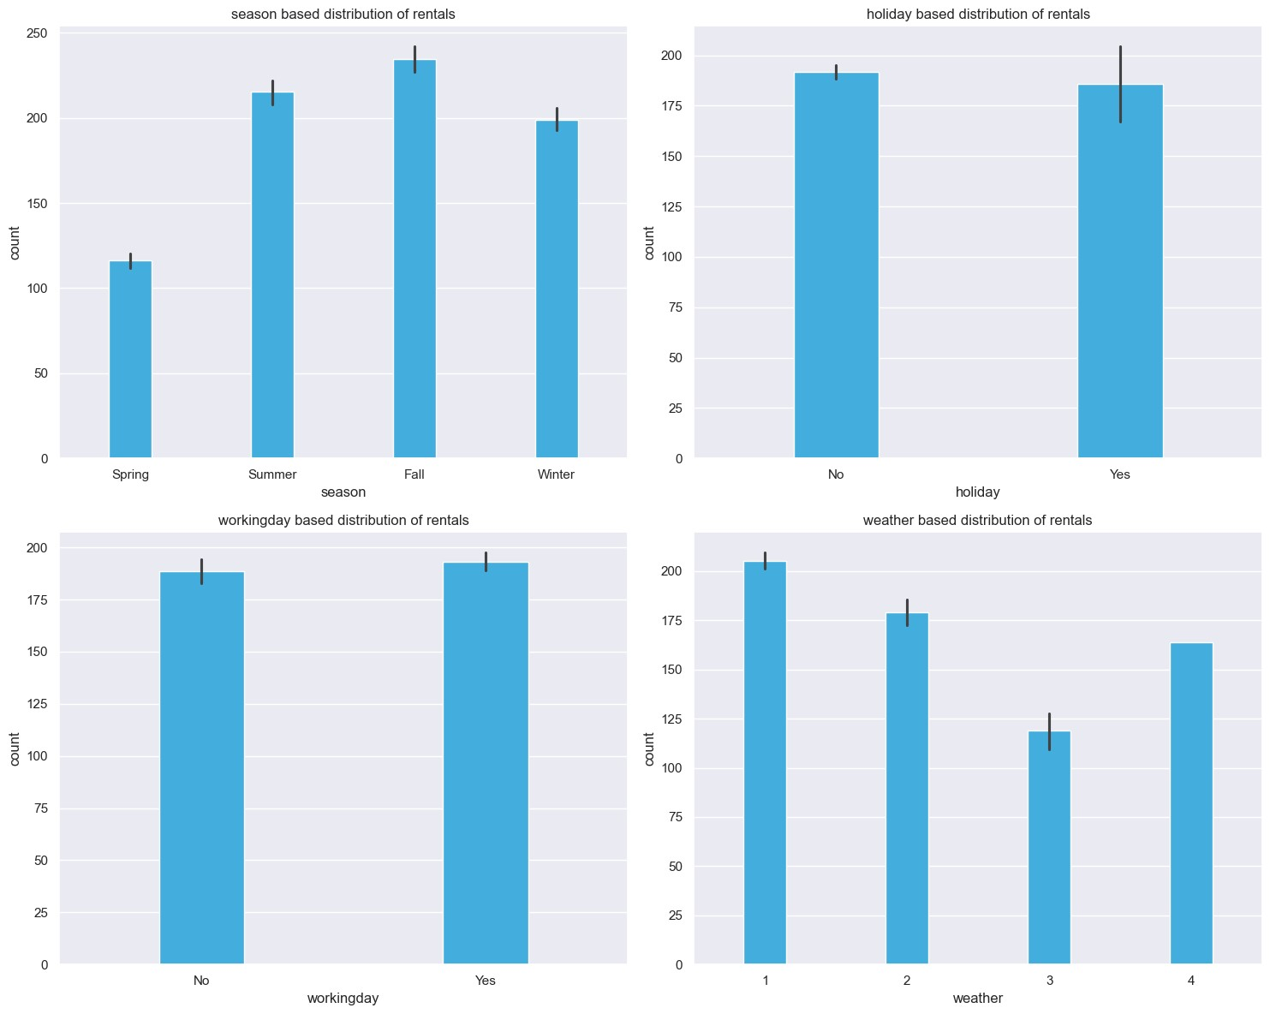

Out[34]:

*# barplot of categories*

plt

.

figure

(

figsize

**=**

(

15

,

12

))

sns

.

set

(

style

**=**

"darkgrid"

)

**for**

i

,

column

**in**

enumerate

(

cat_col

,

1

):

plt

.

subplot

(

2

,

2

,

i

)

sns

.

barplot

(

x

**=**

column

,

y

**=**

'count'

,

data

**=**

df

,

color

**=**

"#29B6F8"

,

width

**=**

0.3

)

plt

.

title

(

f'

{

column

}

based distribution of rentals'

)

plt

.

tight_layout

()

plt

.

show

()

*# corrrelation analysis*

correlation_matrix

**=**

df

[[

"atemp"

,

"temp"

,

"humidity"

,

"windspeed"

,

"casual"

,

correlation_df

**=**

pd

.

DataFrame

(

correlation_matrix

)

correlation_df

**atemp temp humidity windspeed casual registered count**

|  |  |  |  |  |  |  |  |
| --- | --- | --- | --- | --- | --- | --- | --- |
| **atemp** | 1.000000 | 0.984948 | -0.043536 | -0.057473 | 0.462067 | 0.314635 | 0.389784 |
| **temp** | 0.984948 | 1.000000 | -0.064949 | -0.017852 | 0.467097 | 0.318571 | 0.394454 |
| **humidity** | -0.043536 | -0.064949 | 1.000000 | -0.318607 | -0.348187 | -0.265458 | -0.317371 |
| **windspeed** | -0.057473 | -0.017852 | -0.318607 | 1.000000 | 0.092276 | 0.091052 | 0.101369 |
| **casual** | 0.462067 | 0.467097 | -0.348187 | 0.092276 | 1.000000 | 0.497250 | 0.690414 |
| **registered** | 0.314635 | 0.318571 | -0.265458 | 0.091052 | 0.497250 | 1.000000 | 0.970948 |
| **count** | 0.389784 | 0.394454 | -0.317371 | 0.101369 | 0.690414 | 0.970948 | 1.000000 |

In

[35]:

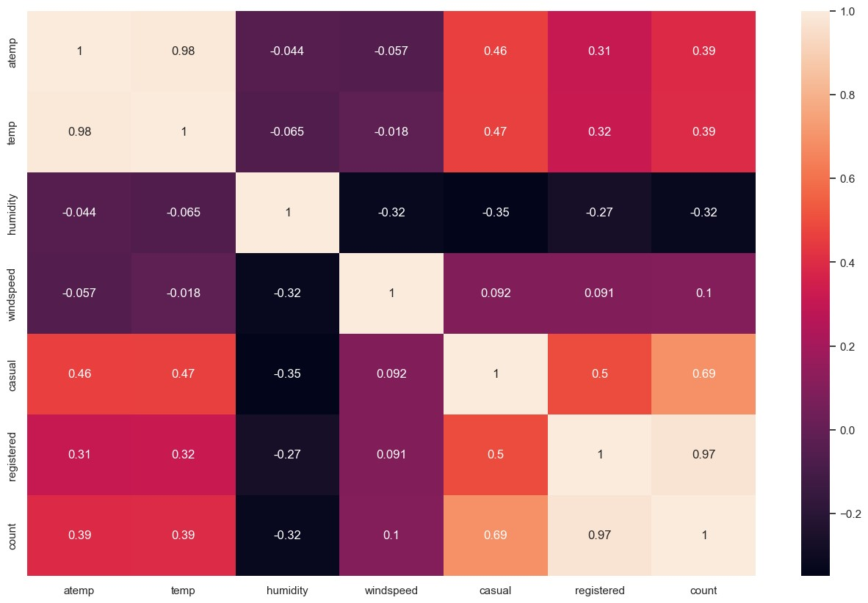

*# correlation chart*

plt

.

figure

(

figsize

**=**

(

16

,

10

))

sns

.

heatmap

(

correlation_matrix

,

annot

**=**

**True**

)

plt

.

show

()

**Correlation Analysis Atemp:**

Strong positive correlation with 'temp' (0.98), indicating a close relationship.

Moderate positive correlation with 'casual' (0.46) and 'registered' (0.31). Positive correlation with 'count' (0.39), suggesting a relationship with overall bike rentals.

**Temp (Temperature):**

Highly correlated with 'atemp' (0.98), indicating a strong connection.

Moderate positive correlation with 'casual' (0.47) and 'registered' (0.32).

Positive correlation with 'count' (0.39), showing a relationship with overall bike rentals.

**Humidity:**

Weak negative correlation with 'atemp' (-0.04) and 'temp' (-0.06).

Moderate negative correlation with 'casual' (-0.35), 'registered' (-0.27), and 'count' (-0.32).

Indicates a tendency for fewer bike rentals during higher humidity.

**Windspeed:**

Weak negative correlation with 'atemp' (-0.06) and 'temp' (-0.02).

Weak positive correlation with 'casual' (0.09), 'registered' (0.09), and 'count' (0.10).

Suggests a subtle influence on bike rentals with increasing wind speed.

**Casual (Casual Bike Rentals):**

Strong positive correlation with 'atemp' (0.46) and 'temp' (0.47).

Moderate negative correlation with 'humidity' (-0.35) and positive correlation with 'windspeed' (0.09).

Highly correlated with 'registered' (0.50) and 'count' (0.69), indicating a significant impact on overall rentals.

**Registered (Registered Bike Rentals):**

Positive correlation with 'atemp' (0.31) and 'temp' (0.32).

Negative correlation with 'humidity' (-0.27) and positive correlation with 'windspeed' (0.09).

Highly correlated with 'casual' (0.50) and 'count' (0.97), emphasizing a substantial impact on overall rentals.

**Count (Total Bike Rentals):**

Positive correlation with 'atemp' (0.39), 'temp' (0.39), and 'casual' (0.69).

Negative correlation with 'humidity' (-0.32).

Highly correlated with 'registered' (0.97), emphasizing the joint impact of casual and registered rentals on the overall count.

In

[36]:

Out[36]:

*# counts based on months*

monthly_count

**=**

df

.

groupby

(

'month'

)[

'count'

].

sum

().

reset_index

()

monthly_count

**=**

monthly_count

.

sort_values

(

by

**=**

'count'

,

ascending

**=**

**False**

)

monthly_count

**month count**

|  |  |  |
| --- | --- | --- |
| **6** | June | 220733 |
| **5** | July | 214617 |
| **1** | August | 213516 |
| **11** | September | 212529 |
| **10** | October | 207434 |
| **8** | May | 200147 |
| **9** | November | 176440 |
| **0** | April | 167402 |
| **2** | December | 160160 |
| **7** | March | 133501 |
| **3** | February | 99113 |
| **4** | January | 79884 |

In

[37]:

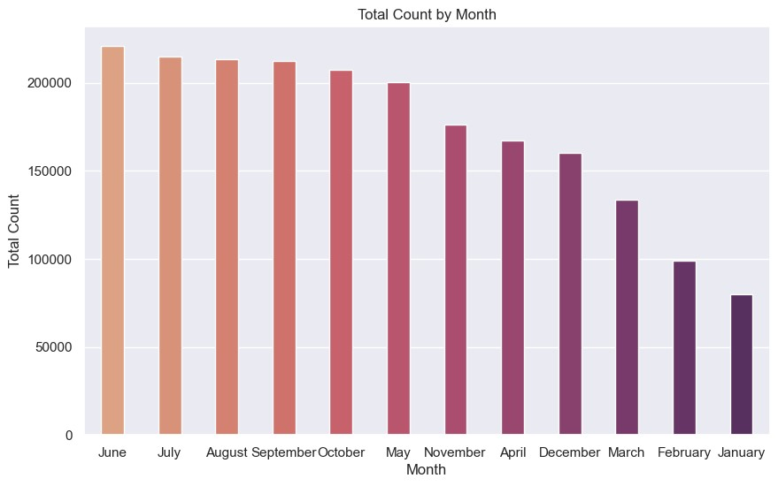

*# rentals on monthly counts*

plt

.

figure

(

figsize

**=**

(

10

,

6

))

sns

.

barplot

(

x

**=**

'month'

,

y

**=**

'count'

,

data

**=**

monthly_count

,

palette

**=**

'flare'

,

width

plt

.

title

(

'Total Count by Month'

)

plt

.

xlabel

(

'Month'

)

plt

.

ylabel

(

'Total Count'

)

plt

.

show

()

**Monthly analysis on rentals Peak Rental Months:**

June stands out as the peak month for bike rentals, with the highest count of 220,733, followed closely by July and August.

**Seasonal Trend:**

Summer months (June, July, August) show higher bike rental counts, consistent with favorable weather conditions.

**Off-Peak Rental Months:**

January, February, and March have notably lower bike rental counts, indicating potential off-peak periods, possibly influenced by colder weather or fewer outdoor activities.

# Hypothesis Testing

## Demand of bicycles on rent is the same on Weekdays & Weekends

Since we have two independent saples, we can go with Two Sample Independent T-Test.

**Assumptions of Two Sample Independent T-Test : The data should be normall distributed**

**variances of the two groups are equal**

**Let the Confidence interval be 95%, so siginificance (alpha) is 0.05**

**To check if the data is normal, we will go with WilkinShapiroTest.**

**The test hypothesis for the Wilkin-Shapiro test are:**

**Ho: Data is normally distributed**

**Ha: Data is not normally distributed.**

In

[38]:

Out[38]:

2.6341072612012795e-07

np

.

random

.

seed

(

41

)

df_subset

**=**

df

.

sample

(

100

)[

"count"

]

test_stat

,

p_val

**=**

shapiro

(

df_subset

)

p_val

Hence the p_values is lesser than the significance level, Null hypothesis can be rejected.

**Therefore, the Data is not normally distributed.**

## QQ Plot analysis

In

[39]:

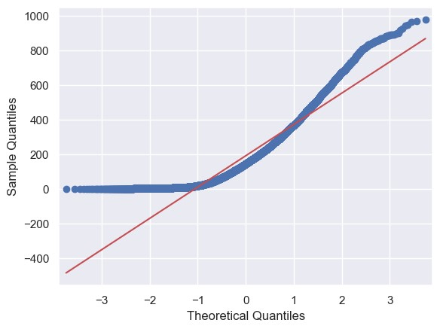

*# QQ plot*

qqplot

(

df

[

'count'

]

,

line

**=**

's'

)

plt

.

show

()

## To check if the variances of two groups are equal. We will perform Levene's test

**The Test hypotheses for Levene's test are:**

**Ho: The variances are equal.**

**Ha: The variances are not equal.**

In

[40]:

Out[40]:

0.9437823280916695

working_day

**=**

df

[

df

[

'workingday'

]

**==**

'Yes'

][

'count'

]

holiday

**=**

df

[

df

[

'workingday'

]

**==**

'No'

][

'count'

]

levene_stat

,

p_val

**=**

levene

(

working_day

,

holiday

)

p_val

In [41]: sns.kdeplot(data **=** df, x **=** 'count', hue **=** 'workingday')

Out[41]: <Axes: xlabel='count', ylabel='Density'>

In

[61]:

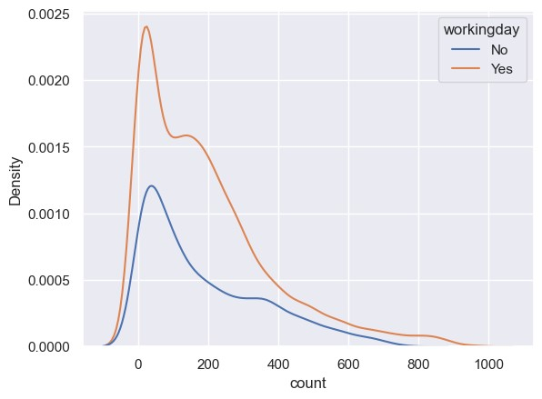

sns

.

histplot

(

data

**=**

df

,

x

**=**

'count'

,

hue

**=**

'workingday'

)

Out[61]: <Axes: xlabel='count', ylabel='Count'>

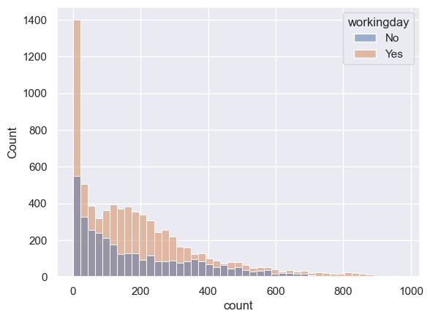

Hence the p_values is greater than the significance level, Null hypothesis can be accepted.

**Therefore, the variances are approximately equal.**

Despite the data is not normally distributed according to both the Wilkin-ShapiroTest and qqplot

It is important to highlight that the variances between the two groups are equal** **So we can proceed with the Two Sample Independent T-Test.**

**The hypothesis for the t-test are:**

**Ho: There is no significant difference between working and non-working days.**

**Ha: There is a significant difference between working and non-working days.**

In

[43]:

Out[43]:

0.22644804226361348

ttest_stat

,

p_val

**=**

ttest_ind

(

working_day

,

holiday

)

p_val

Hence the p_values is greater than the significance level, Null hypothesis can be accepted.

**Therefore, There is no significant difference on bike rentals between working and non-working days.**

In

[44]:

kruskal_stat

,

p_val

**=**

kruskal

(

working_day

,

holiday

)

p_val

Out[44]: 0.9679113872727798

Hence the p_values is greater than the significance level, Null hypothesis can be accepted.

**Therefore, There is no significant difference on bike rentals between working and non-working days.**

## Demand of bicycles on rent is the same for different Weather conditions

Since we have more than two categories now, so will use ANOVA here.

**Assumptions for ANOVA are:**

1. The population data should be normally distributed- The data is not normal as verified by **Wilkin-Shapiro test and the qqplot.**
2. The data points must be independent- This condition is satisfied.
3. Approximately equal variance within groups- This will be verified using **Levene's test.**

In

[45]:

*# skewness of weather*

df

.

groupby

(

'weather'

)[

'count'

].

skew

()

Out[45]: weather

1. 1.139857
2. 1.294444
3. 2.187137
4. NaN

Name: count, dtype: float64

In

[46]:

*# kurtosis test of weather*

df

.

groupby

(

'weather'

)[

'count'

].

apply

(

**lambda**

x

:

x

.

kurtosis

())

Out[46]: weather

1. 0.964720
2. 1.588430
3. 6.003054
4. NaN

Name: count, dtype: float64

In

[47]:

sns

.

kdeplot

(

data

**=**

df

,

x

**=**

'count'

,

hue

**=**

'weather'

)

Out[47]: <Axes: xlabel='count', ylabel='Density'>

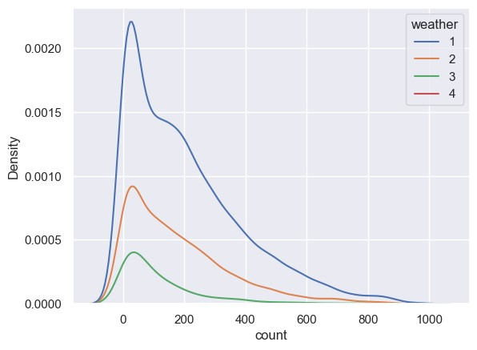

In [48]: sns.histplot(data **=** df, x **=** 'count', hue **=** 'weather')

Out[48]: <Axes: xlabel='count', ylabel='Count'>

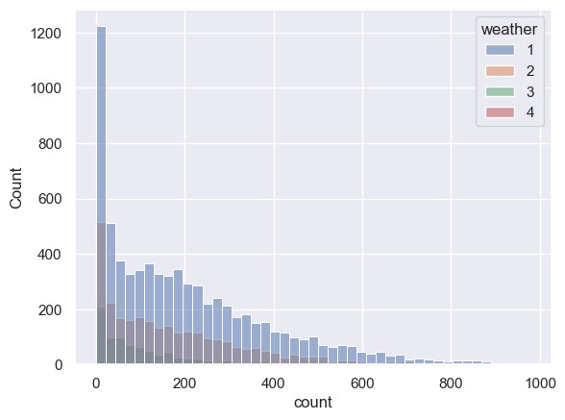

**The Test hypothesis for Levene's test are:**

**Ho: The variances are equal.**

**Ha: The variances are not equal.**

In

[49]:

Out[49]:

3.504937946833238e-35

weather1

**=**

df

[

df

[

'weather'

]

**==**

1

][

'count'

]

weather2

**=**

df

[

df

[

'weather'

]

**==**

2

][

'count'

]

weather3

**=**

df

[

df

[

'weather'

]

**==**

3

][

'count'

]

weather4

**=**

df

[

df

[

'weather'

]

**==**

4

][

'count'

]

levene_stat

,

p_val

**=**

levene

(

weather1

,

weather2

,

weather3

,

weather4

)

p_val

Hence the p_values is smaller than the significance level, Null hypothesis can be rejected.

**Therefore, the variances are not equal.**

Two of the three conditions of ANOVA are not met, **We will still perform ANOVA**.

Then We will also perform **Kruskal's test and compare the results**.

In case of any discrepancies, Kruskal's test results will be considered, since data does not met conditions of ANOVA.

**The hypothesis for ANOVA are:**

**Ho: There is no significant difference between demand of bicycles for different Weather conditions.**

**Ha: There is a significant difference between demand of bicycles for different Weather conditions.**

In

[50]:

anova_stat

,

p_val

**=**

f_oneway

(

weather1

,

weather2

,

weather3

,

weather4

)

p_val

Out[50]: 5.482069475935669e-42

Hence the p_values is smaller than the significance level, Null hypothesis can be rejected.

**Therefore, There is a significant difference between demand of bicycles for different Weather conditions.**

## Kruskal Test on weather

In

[51]:

kruskal_stat

,

p_val

**=**

kruskal

(

weather1

,

weather2

,

weather3

,

weather4

)

p_val

Out[51]: 3.501611300708679e-44

Again the p_values is smaller than the significance level, Null hypothesis can be rejected.

**Therefore, we can conclude that there is a significant difference between demand of bicycles for different Weather conditions.**

## Demand of bicycles on rent is the same for different Seasons

Here also we have more than two categories now, so will use ANOVA here.

**Assumptions for ANOVA are:**

1. The population data should be normally distributed- The data is not normal as verified by **Wilkin-Shapiro test and the qqplot.**
2. The data points must be independent- This condition is satisfied.

3 A i l l i i hi Thi ill b ifi d i **'**

In

[52]:

*# skewness of seasons*

df

.

groupby

(

'season'

)[

'count'

].

skew

()

Out[52]: season

Spring 1.888056

Summer 1.003264

Fall 0.991495

Winter 1.172117

Name: count, dtype: float64

In

[53]:

*# kurtosis test of seasons*

df

.

groupby

(

'weather'

)[

'count'

].

apply

(

**lambda**

x

:

x

.

kurtosis

())

Out[53]: weather

1. 0.964720
2. 1.588430
3. 6.003054
4. NaN

Name: count, dtype: float64

In

[54]:

sns

.

kdeplot

(

data

**=**

df

,

x

**=**

'count'

,

hue

**=**

'season'

)

Out[54]: <Axes: xlabel='count', ylabel='Density'>

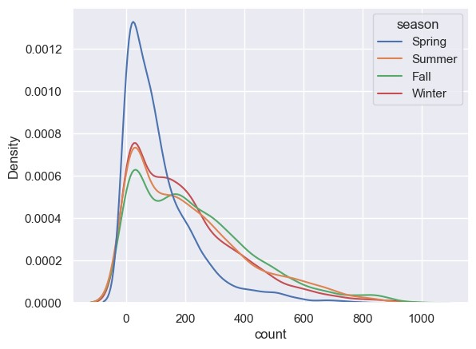

In [55]: sns.histplot(data **=** df, x **=** 'count', hue **=** 'season')

Out[55]: <Axes: xlabel='count', ylabel='Count'>

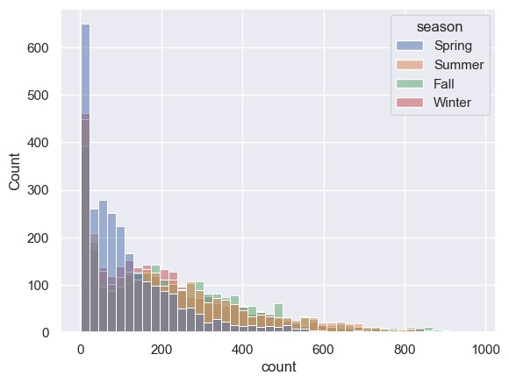

**The Test hypothesis for Levene's test are:**

**Ho: The variances are equal.**

**Ha: The variances are not equal.**

In

[56]:

Out[56]:

1.0147116860043298e-118

spring

**=**

df

[

df

[

'season'

]

**==**

'Spring'

][

'count'

]

summer

**=**

df

[

df

[

'season'

]

**==**

'Summer'

][

'count'

]

fall

**=**

df

[

df

[

'season'

]

**==**

'Fall'

][

'count'

]

winter

**=**

df

[

df

[

'season'

]

**==**

'Winter'

][

'count'

]

levene_stat

,

p_val

**=**

levene

(

spring

,

summer

,

fall

,

winter

)

p_val

Hence the p_values is smaller than the significance level, Null hypothesis can be rejected.

**Therefore, the variances are not equal.**

As like before, we still use both ANOVA and Kruskal's test, comparing the results.

If discrepancies arise, we'll rely on **Kruskal's test**, Since data does not met the conditions for ANOVA.

**The hypothesis for ANOVA are:**

**Ho: There is no significant difference between demand of bicycles for different Seasons.**

**Ha: There is a significant difference between demand of bicycles for different Seasons.**

In

[57]:

anova_stat

,

p_val

**=**

f_oneway

(

spring

,

summer

,

fall

,

winter

)

p_val

Out[57]: 6.164843386499654e-149

Hence the p_values is smaller than the significance level, Null hypothesis can be rejected.

**Therefore, There is a significant difference between demand of bicycles for different Seasons.**

## Kruskal Test on season

In

[58]:

kruskal_stat

,

p_val

**=**

kruskal

(

spring

,

summer

,

fall

,

winter

)

p_val

Out[58]: 2.479008372608633e-151

Again the p_values is smaller than the significance level, Null hypothesis can be rejected.

**Therefore, we can conclude that there is a significant difference between demand of bicycles for different Seasons.**

## Analysis of Weather Conditions Across Seasons using Chi-square Test

**The hypothesis for the chi-square test are:**

**Ho: Season and Weather are independent of each other.**

**Ha: Season and Weather are dependent on each other.**

In

[59]:

contingency_table

**=**

pd

.

crosstab

(

df

[

'weather'

]

,

df

[

'season'

])

contingency_table

Out[59]:

**season Spring Summer Fall Winter**

**weather**

|  |  |  |  |
| --- | --- | --- | --- |
| **1** 1759 | 1801 | 1930 | 1702 |
| **2** 715 | 708 | 604 | 807 |
| **3** 211 | 224 | 199 | 225 |
| **4** 1 | 0 | 0 | 0 |

In

[60]:

chi2_contingency

(

contingency_table

)

Out[60]: Chi2ContingencyResult(statistic=49.15865559689363, pvalue=1.54992507368648 62e-07, dof=9, expected_freq=array([[1.77454639e+03, 1.80559765e+03, 1.805

59765e+03, 1.80625831e+03],

[6.99258130e+02, 7.11493845e+02, 7.11493845e+02, 7.11754180e+02],

[2.11948742e+02, 2.15657450e+02, 2.15657450e+02, 2.15736359e+02],

[2.46738931e-01, 2.51056403e-01, 2.51056403e-01, 2.51148264e-01]]))

Hence the p_values(1.5499250736864862e-07) is smaller than the significance level, Null hypothesis can be rejected.

**Therefore, we can conclude that Season and Weather are dependent on each other.**

## Strategic Recommendations for Yulu's Profitable Growth

**Optimize Bike Distribution in Peak Months:**

Concentrate bike deployment efforts during peak months, especially in June, July, and August, to meet increased demand and capitalize on favorable weather conditions.

**Seasonal Marketing Strategies:**

Tailor marketing efforts to leverage the seasonal trend, promoting Yulu's services more aggressively during summer months to attract a larger user base.

**Enhance User Engagement in Off-Peak Months:**

Implement targeted promotional campaigns or discounts during off-peak months (e.g., January to March) to encourage increased bike rentals and maintain consistent revenue flow.

**Weather-Responsive Pricing:**

Consider implementing dynamic pricing strategies that respond to weather conditions.

For example, adjusting rental rates during extreme weather days to optimize revenue.

**Diversify Revenue Streams:**

Explore additional revenue streams, such as partnerships, sponsorships, or offering premium membership services with added benefits, to diversify income sources and boost overall profitability.

**Enhance User Experience:**

Invest in technology and infrastructure to improve the overall user experience, including app features, bike maintenance, and customer support, fostering loyalty and repeat business.

**Optimize Bike Deployment on Working Days:**

Given the lack of significant differences in bike rentals between working and nonworking days, consider adjusting bike deployment strategies to ensure optimal resource allocation throughout the week.

**Adapt to Different Weather Conditions:**

Change promotions or discounts based on the weather. If it's rainy, for example, offer special deals to encourage more people to use the bikes.

**Promote Bikes Differently in Each Season:**

Advertise the bikes differently in each season. For example, highlight summer promotions in June, July, and August when more people want to ride bikes.

**Combine Season and Weather Plans:**

Plan bike availability based on both the season and the weather to make sure people have the bikes they need when they want them. For example, have more bikes available on sunny days in the summer.